A Guide to CASHING in on Local Recreational Opportunities

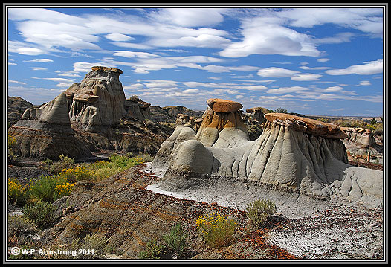

Glendive Recreation Department
  - Connect and Stay Healthy in Glendive, MT
Updated: April 2017
Table of Contents

About the Glendive Recreation Department 3
Aquatics 4-5
Baseball 5
Softball 6
Bowling 6
Movie Theaters/Performing Arts Theatre 7
Fitness Centers/Classes 8-9
AAU Sports/Gymnastics/Dance 9-10
Martial Arts 11
Equine/Canine/Animal Care 11-12
4-H/Fair/Rodeos 13
Scouts/Boys & Girls Club 14
Outdoor Recreation 15-18
Other Activities 18-20
Glendive Parks 21
Trails and Maps 22-27

Glendive Recreation Department

Philosophy
- To promote broad-based recreation opportunities in order to improve the quality of life for the citizens of Glendive and its visitors;
- To increase and enhance the recreational opportunities for all ages, stages and abilities;
- To increase the understanding of the contributions made by recreation to the economic development of Glendive.
“The Recreation Department is responsible for the recreation of the community – planning, organizing and directing the activities.”
The Glendive Recreation Department offers a variety of Recreation, seasonal jobs, open gym, adult programs and youth programs throughout the year. Some of our programming and occupations include:
Men’s Basketball Leagues Challenger Sports British
Junior Jazz Basketball Soccer Cup
(3rd & 4th Grades) Youth Soccer
Volleyball Leagues Horseshoe Rentals
(Women’s & Co-Ed) Open Gym
Youth Volleyball Leagues Foosball & Ping Pong
Badminton Park Program Summer Camps
Tennis Lessons Cross Country Ski Rentals
Hoole Tennis Tournament Lifeguarding
Swimming Lessons Instructors, Referees,
Water Olympics Program Leaders & Etc.
Phone: 406-377-5471
Email: recdept@midrivers.com
Website: www.glendiverec.com
Things to Do, Places to Go

Aquatics
Name: Glendive Pool
Address: Lloyd Square Park (1000 block of N. Meade), Glendive
Phone: 406-377-5471 or 406-377-POOL (7665)
Contact: Glendive Recreation Department
Email: recdept@midrivers.com
Facebook: Glendive Rec Department
Website: www.glendiverec.com
For: Everyone
Open: June-August
Offering: Open swim, Lap Swim and Swimming Lessons.
Check website for times, classes and rates.

Name: Splash Park
Address: Whipkey Park
Phone: 406-377-5471
Contact: Dean Svenvold or Jacquie Marquart
Email: recdept@midrivers.com
Website: www.glendiverec.com
Facebook: Glendive Rec Department
For: Everyone
Hours: 10:00 AM – 7:30 PM during the summer.

Name: Wet Devils Swim Team
Phone: 406-939-4352 (Lara) 406-939-3595 (Kami)
Contact: President: Lara Crighton Secretary: Kami White
Email: wet.evils@gmail.com
Website: www.sites.google.com/site/wetdevils
Facebook: Glendive Wet Devils Swim Team
For: Members must be able to swim the width of the pool and can compete until senior year.
Season: June 1st- August 1st. Sign-ups: April 20th and 27th
Offering: Swimming at a competitive level to keep athletes challenged and active.
Aquatics (Continued)
Name: Water Aerobics at Comfort Inn
Address: 1918 North Merrill Avenue, Glendive
Phone: 406-365-6000
Contact: Ann Hoff
For: Everyone
Hours: MWF 6:00 AM – 7:00 AM and 7:00 AM – 8:00 AM
Offering: Water exercise

Baseball
Name: Babe Ruth Baseball
Phone: 406-939-9171
Contact: PJ Knoll
Facebook: Glendive Babe Ruth Baseball
For: Boys ages 13 to 15 years old
Season: May through July
Offering: Baseball games and practices are played throughout the season playing against other league teams in a healthy and competitive way.

Name: Glendive Blue Devils
Contact: Brent Diegel, Bob Buxbaum or Jennifer Rieger
Email: diegel@midrivers.com
Facebook: Glendive Blue Devils Baseball
For: Boys 16 through 18 years old.
Season: May through August.
Offering: An American Legion traveling baseball team playing 50- 60 games per season.

Name: ABC Cal Ripken Baseball
Phone: 406-377-7242
Contact: President: Tyler Silha
Website: www.glendive.baberuthonline.com
Facebook: Glendive ABC Baseball
For: Boys and Girls ages 5-12 years old.
Season: April through July
Offering: T-ball for 5-6 year olds. Graduated baseball divisions for ages 7-8, 9-10 and 11-12 year olds.
Softball
Name: Glendive Co-Ed Softball
Phone: 406-939-5977
Contact: Tony Monson or other board members
Email: tonym@crisafulli.com
Facebook: Glendive Co-Ed Softball
For: Everyone 16 years and older
Season: June through August. Games played on Fridays, Saturdays and some Sundays
Offering: Teams are 5 men and 5 women active on the field. Season ends with a two day tournament.

Name: Glendive Girls Softball Association (GGSA)
Address: P.O. Box 252, Glendive
Contact: President: Chad Maher 406-941-2892
VP: Lesa Schock 406-939-4501
Facebook: Glendive Girls Softball Association
For: Boys ages 4-5 year olds. Girls 4-14 years old.
Offering: T-ball for boys and girls ages 4-5. Coach-pitch for girls 6- 8 years old and fast pitch for girls 9-11 years old and 12- 14 years old.

Bowling
Name: Glen Bowl Lanes & Storage
Address: 2802 West Towne Street, Glendive
Phone: 406-365-5316
Contact: Joe Kessel
Email: jobowler@midrivers.com
Facebook: ROSE Theatre
For: Everyone
Hours: Monday – Sunday 1:00 PM – Close.
Offering: Bowling, Competitive Leagues (Men, Women, Early Bird, 9 Pin No-Tap, Youth and Co-Ed) and open bowling. The bowling alley also has a small café menu that serves limited food and drinks. Also located at the facility is a casino with live poker (on available nights), lounge and gambling machines. Storage facility is available.
Movie Theater/Performing Arts Theatre
Name: ROSE Theatre
Address: 2802 West Towne Street, Glendive
Phone: 406-365-5316 Movie Hotline: 406-377-2828
Contact: Joe Kessel
Email: jobowler@midrivers.com
Facebook: ROSE Theatre
For: Everyone
Show Hours: Monday – Sunday 5:30 PM and 7:30 PM (varies depending on shows) and Sunday 1:00 PM Matinee.
Offering: Multiple movie theater and screen showings per night. One movie theater stage is active now doing movie showings and averages two movies per night. Construction of the second screen stage theater is moving forward to completion.

Name: The Retro Theatre
Address: 215 North Merrill, Glendive
Phone: 406-377-7977
Contact: Christy Burry
Email: hellcreek@midrivers.com
Facebook: The Retro Theatre
Website: www.theretrotheatre.com
For: Everyone
Hours: See website for upcoming events and times.
Offering: A single stage/screen theatre built in 1918. The theatre features live performances from bands, comedians, plays and more.

Fitness Centers/Classes
Name: Black Bridge Fitness Center
Address: 420 South Merrill Avenue, Glendive
Phone: 406-377-7777
Contact: Donna Houck
For: Everyone
Hours: 24/7 with Keyless entry for members.
Offering: Weights, cardio, racquetball, walleyball, basketball, tanning, sauna and private women’s area.
Fitness Centers/Classes (Continued)
Name: Body & Soul Gym
Address: 115 West Bell Street, Glendive
Contact: Teresea Olson
Email: TolsonPAC@hotmail.com
Facebook: Body N Soul Gym
For: Everyone
Hours: 24 hour key fob access, various staffed hours Mon-Fri
Offering: Cardio equipment, weights, and circuit training and yoga.

Name: DCC Toepke Center
Address: 300 College Drive, Glendive
Phone: 406-377-3396
Website: www.dawson.edu
Facebook: Dawson Community College
For: Everyone
Hours: Mon– Fri: 7:00 AM -3:00 PM and 6:00 PM – 10:00 PM. Sat- Sun: 2:00 PM- 4:00 PM Summer Hours: 7:00 AM - 3:00 PM
Offering: Indoor walking track, weight machines, free weights and cardio equipment. Check out website for “100 Mile Walking Club.”

Name: Momentum Fitness Inc.
Address: 1515 West Bell, Suite C; Glendive
Phone: 406-891-0017
Contact: Jodee Davison-Lantis
Facebook: Momentum Fitness Inc.
For: Everyone
Hours: Mon-Fri 5:00 AM-8:00 AM, Saturday 6:00AM- 10:00 AM
Offering: Yoga, Zumba, Strong by Zumba, PiYo, Cardio Burn, Muscle Pump, Kick Boxing, Boot Camp, Challenge Groups, Personal Training, Kids Fitness and Open Gym.

Name: Crossfit Glendive
Address: 418 East Slocum, Glendive
Contact: Sami Aldinger or Sarah Dinardi
Email: sami@crossfitglendive.com
Website: www.crossfitglendive.com
For: Everyone
Offering: Functional Fitness, muscle ropes, cardio and more.
AAU Sports/Gymnastics/Dance
Name: Glendive Mat Devils Wrestling
Address: Eastern Plains and Event Center; 313 S. Merrill Ave
Contact: Darci Ochs
Email: dochs@gmail.com
Facebook: Glendive Mat Devils
For: Youth 5 – 18 years old.
Season: January through April
Offering: Wrestling instruction and mentorship. Competition is not required, but many members travel to several tournaments throughout the season.

Name: Glendive Knights Football
Contact: Paul Miller 406-939-4461
Ryan Buckley 406-939-0774
For: Boys 4th – 6th Grade
Season: Mid-August through October
Offering: An opportunity for young boys to learn tackle football basics and to compete with teams from other Montana towns.

Name: Dawson County Volleyball Club
Phone: 208-490-7339
Contact: Tiffaney Egan
Facebook: Dawson County Volleyball
Email: Dtegan@yahoo.com
For: Girls 10 – 18 years old.
Season: March through Beginning May.
Try Outs: Mid-February
Offering: AAU/USA Volleyball sanctioned tournaments and practices available. Tournaments are 12 and under, 14 U, 16 U and 18 U.

Glendive Swimming Pool
AAU Sports/Gymnastics/Dance (Continued)
Name: Devil Dog Gymnastics
Address: In West Plaza at 1515 Bell Street, Glendive
Phone: 406-852-3881
Contact: Jamie Rechwine
Email: devildoggymnastics@gmail.com
Facebook: Devil Dog Gymnastics or
Devil Dog Gymnastics Booster Club
For: 18 months – 16 years old.
Hours: Monday through Thursday 3:30 PM – 7:00 PM
Offering: Infant/Parent classes, Preschool classes, advanced floor tumbling, recreational gymnastics and competitive gymnastics. Facility also available for birthday parties.

Name: LaDonna’s School of Dance
Address: 603 Regal Street, Glendive
Phone: 406-365-6677
Contact: LaDonna Jimison
Email: jjimison@midrivers.com
Facebook: LaDonna’s School of Dance
For: Youth Ages 3 – 18 years old, occasional adult classes
Hours: Sunday through Thursday 3:30 PM – 9:00 PM. September through May.
Offering: Classes in ballet, pointe, tap, jazz, clog and hip hop. Students perform in the annual production of “The Nutcracker”, a spring recital, many community events and nationally affiliated competitions.
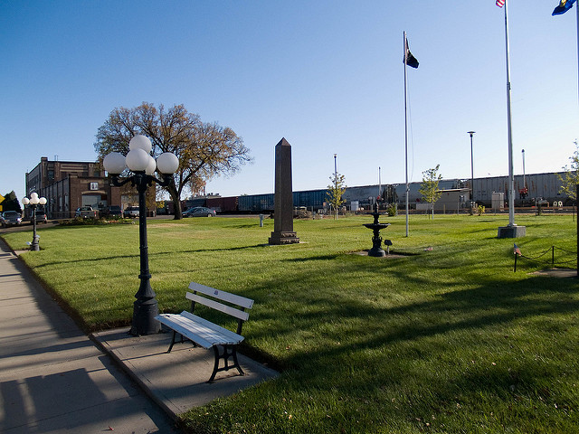
BNSF Railroad; Glendive, MT
Martial Arts
Name: Eastern Montana Martial Arts Academy
Address: 1515 West Bell Street Suite G, Glendive
Phone: 406-939-4835
Contact: Mr. Jacob Martin 3rd Dan Taekwondo Black Belt, 1st Dan (KHA) Hapkido Black Belt
Email: jacobmartin_390@hotmail.com
Website: www.emmaa.net
Facebook: Eastern Montana Martial Arts Academy
For: Ages 7 years old to Adult
Hours: Children: Tuesday & Thursday 5:30 PM – 6:15 PM
Juniors/Adults: Tuesday & Thursday 6:30 PM – 7:30 PM
Offering: Taekwondo and Hapkido training from beginner to Black Belt levels. Total Martial Arts training that focuses on the student and their personal development. Students learn to respect, discipline, self-defense, self- control and good manners while building their confidence and self-esteem. Sparring classes offered at the Instructor’s discretion.

Equine/Canine/Animal Care
Name: Big Sky Shires & Equine Services
Address: 285 Highway 200 South, Glendive
Phone: 406-687-3004
Contact: LeAnne Hoagland
Email: bsshires@midrivers.com
Website: www.bigskyshires.com
Facebook: Big Sky Shires & Equine Services
For: Everyone
Offering: Group or private lessons in Showmanship, English, Western, Driving and Horse Care/Management. Check our website for other services offered.

Name: Glendive Arena
Address: 145 Rd 240, Glendive
Facebook: Glendive Arena
Email: jnaareana6872110@yahoo.com
Offering: Indoor riding arena, equine boarding and clinics.
Equine/Canine/Animal Care (Continued)
Name: Lazy Hearts Kennel
Address: Glendive, MT
Phone: 406-989-2480
Contact: Nancy Lane
Email: lzyharts@midrivers.com
Website: www.lazyheartskennel.net
For: Everyone
Season: Sex week group classes offered in spring and fall.
Offering: Basic dog obedience and dog show conformation handling. Behavior issue solutions for owners and their dogs. “AKC Canine Good Citizen” and “Love on a Leash” evaluator and testing. Private training/behavior sessions by appointment.

Name: Pet Projects
Address: 1108 West Towne Street, Glendive
Phone: 406-365-9013
Fax: 406-365-9004
Contact: Allen Deines
Email: Petprojectskenneling@gmail.com
Website: www.facebook.com/PetProjectsKenneling
For: Everyone with Pets
Hours: Monday through Friday 7:30 PM – 4:00 PM.
Closed for Holidays. Exceptions are for dog drop-offs and pick-ups at 7:00 AM, 12:00 PM, 4:00 PM and 8:00 PM.
Offering: Kenneling, Dog Daycare and Boarding. See Facebook or contact Allen for details on pricing, kennel/room sizing and medical and/or vaccination requirements.

Name: Eastern Montana Horse Show Circuit
Phone: 406-377-7706
Contact: Jen Haas
Email: easternmthorseshowcircuit@gmail.com
Website: www.easternmthorseshow.wixsite.com
Facebook: Eastern Montana Horse Show Circuit
Season: May – July. Show Clinic- May 6, 2017
Glendive Show: June 10-11, Miles City: June 24-25, Circle: July 8-9 and Wibaux: July 29-30.
Offering: Horse show circuit that is open to all breeds of horses and for all ages for everyone to enjoy.
4-H/Fair/Rodeos
Name: Dawson County 4-H Council
Address: 207 West Bell Street (Mailing)
Dawson County Courthouse- 2nd floor (Physical)
Phone: 406-377-4277
Contact: Bruce Smith (County Agent) or
Jackie Stinnett (4-H Assistant)
Email: dawson@montana.edu
Website: www.dawsoncountymontana.org
Facebook: Dawson County, MT 4-H

Name: Dawson Count Fair Board
Address: 2200 North Merrill (Physical)
207 West Bell St (Mailing)
Phone: 406-377-6781
Contact: Tacee DeSaye
Email: dcfair@midrivers.com
Website: www.dawsonfair.com
Fair: August 10th -13th, 2017
Events: Tickets are available for purchase on the website and available with the Fair Board. Sled Pull August 10, 2017 @ 7:00 PM; PRCA Rodeo Adult August 11th, 2017 @ 7:00 PM; Concert: SEETHER August 12th, 2017 @ 9:00 PM; Ranch Rodeo August 13th, 2017.

Scouts/Boys & Girls Club
Name: Boy Scouts of America
Phone: Jonathon: 406-377-6012 or 406-939-4584
Justin: 406-377-4618
Contact: Jonathon Westenskow or Justin Cross
Email: jon.westenskow@live.com jnlcross@midrivers.com
Website: www.scouting.org or www.montana.bsa.org
Facebook: Boy Scout Troop 139 Glendive Montana
For: Boys 1st grade to 21 years old; Girls 14 to 21 years old.
Hours: Varies
Offering: Cub Scouts (boys 1st grade to 18 years old), Boy Scouts (boys 11-18 years old) and Venturing (Co-Ed 14-21 years old). Call to connect with a troop/pack.
Scouts/Boys & Girls Club (Continued)
Name: Cub Scouts Pack 111
Phone: 406-939-7859
Contact: Jay Fleming
Email: caessar95@gmail.com
Website: www.scouting.org
Facebook: Glendive Pack 111
For: Boys 1st grade to 18 years.

Name: Glendive Girl Scouts Troop 2323
Address: Glendive Alliance Church Basement
Phone: 503-758-8760
Contact: Tricia Rittal
Email: tricia.splichal@gmail.com
Website: www.gsmw.org
Facebook: Glendive Girl Scouts
For: Girls aged kindergarten to high school seniors.
Meetings: Varies

Name: Boys and Girls Club of Dawson County
Address: 111 West Bell St
Phone: 406-377-7999
Fax: 406-377-7888
Contact: Tina Carter
Email: bgc@midrivers.com
Website: www.boysandgirlsclubofdawsoncounty.com
Facebook: Boys and Girls Club of Dawson County
For: Children
Hours: Usually after school hours.
Monday through Friday 2:00 PM – 6:00 PM. Operates with the school system. If there is no school, we will be closed as well.
Offering: A safe place to learn and grow with ongoing relationships with caring adults. The club falls under five categories: To build character and leadership development, educational development, health and life skills, the arts; sports, fitness and recreation.

Outdoor Recreation
Name: Glendive Community Shooting Range
Address: Highway 200 West/ 4 Miles North West of Highway 94
Phone: 406-377-6256
Contact: Makoshika State Park
Email: makoshika@mt.gov
For: Everyone
Hours: Dawn to Dusk
Offering: The shooting range is open for all shooting activities, except shotguns and .50 cal. No homemade targets or clay birds allowed.

Name: Makoshika State Park
Address: 1301 Snyder Avenue, Glendive
Phone: 406-377-6256
Contact: Park Manager: Chris Dantic
Park Manager: Tom Shoush
Email: makoshika@mt.gov
Website: www.stateparks.mt.gov/makoshika/
Facebook: Makoshika State Park
Hours: The Park is open 24 hours and 7 days a week for visiting access. The Visitor Center is open 10:00 AM – 5:00 PM. Closed Holidays.
Offering: With the park size of 11,531 acres of badlands makes Makoshika the largest state park in Montana. Available in the park are: hiking trails, an archery range, disc golf course, amphitheater, group shelter, campgrounds and primitive camping. The Park also offers a Visitor Center (located at the entrance of the park) that offers interpretive displays (including a Triceratops Dinosaur Skull) and a gift shop. Many events and activities are held throughout the summer including: Campfire Program, Buzzard Days, Youth Program, Movies Under the Stars and Montana Shakespeare in the Park. Contact the Visitor Center or website for more info.

Outdoor Recreation (Continued)
Name: Glendive Outside
Contact: Kelly Wicks
Email: Glendiveoutside@gmail.com
Websites: www.glendiveoutside.org
www.glendiveoutside.wordpress.com
Facebook: Glendive Outside
For: Everyone
Hours: Check Facebook for upcoming events. All Season.
Offering: Glendive Outside was created to build a social community of like-minded people who enjoy outdoor recreational activities.

Name: Glendive Short Pine OHV Area
Address: Six and a half miles south of Glendive on FAS 335
Phone: 406-233-2800
Contact: Dena Lang
Email: dslang@blm.gov
Website: www.blm.gov.mt
Facebook: Bureau of Land Management – Montana/Dakotas
Hours: 24 hours/7 days year round
Offering: 2,240 acres of public land for OHV trails, a shooting area, fossil collecting, wildlife viewing and primitive camping.

Name: Glendive Trap Club
Address: 460 Colorado Blvd (beside Dawson County Correctional Facility), Glendive.
Phone: 406-377-7261
Contact: Roger Redland or Jeff Diegel
Email: jeffd@midrivers.com
For: Anyone who has (preferably) taken a Hunter’s Safety Course.
Hours: Wednesday and Friday 5:00 PM – 7:00 PM, Sunday 12:00 PM – 3:00 PM. April 30th through September 30th.
Offering: Trap/Skeet shooting. League or practice all spring and summer. Offer special shoots, a turkey shoot and other games.

Outdoor Recreation (Continued)
Name: Makoshika Bowman
Address: Makoshika State Park
Phone: 406-377-2994
Contact: Ed Williamson or Makoshika State Park 377-6256
For: Members
Season: May 1st through October 15th.
Offering: The archery range has two scenic and challenging courses with groomed trails and approximately 14 targets on each course. It takes about 45 minutes for each course to complete. We have a 3-D Shoot on Father’s Day weekend.

Name: Badlands Geocaching Group
Phone: 406-377-8992
Contact: Naomi Burbach
Email: nabur@midrivers.comg
Website: www.badlandsgeocachinggroup.webs.com
Facebook: Badlands Geocaching Group
Offering: A group for all the cachers in Easter Montana and Western North Dakota. Check out our website for more information on upcoming meetings and events.

Name: Brett Fitch Memorial Skate Park
Address: Physical- Across the parking lot from Alberts
Mailing- Fitch Foundation; PO Box 108; Glendive
Phone: 406-989-1206
Contact: President- Brenda Rose
Website: www.fitchfoundationmt.org/park/
For: Everyone
Hours: Daylight Hours
Offering: A drug-free, premier skate park where skaters can exercise, be creative, develop leadership and mentoring skills and boost youth self-esteem in a clean and safe environment without endangering people or damaging property.

Outdoor Recreation (Continued)
Name: Cottonwood Country Club
Address: 504 Country Club Drive, Glendive
Phone: 406-377-8797
Contact: Chuck Page
Email: ccgs@midrivers.com Cottonwoodcc@midrivers.com
Website: www.cottonwoodcc.com
For: Everyone
Hours: Daybreak to Sunset
Offering: A nine-hole golf course, driving range, practice green, pro shop and a fully stocked lounge.

Other Activities
Name: Glendive Community Orchestra
Phone: 406-670-6121 or 406-377-1143
Contact: Sonja Tuma
Email: mrs.s.tuma@gmail.com
Facebook: Glendive Community Orchestra
For: People with at least 2-3 years experience playing their instrument(s). (On extended break, contact Sonja)
Offering: Weekly rehearsals to prepare for performances around the community: Nursing homes, community events, church appearances and concerts.

Name: SubZero Skating
Address: 415 North Merrill Ave. Basement of the Moose Lodge
Phone: 406-939-2804
Contact: Staci
Facebook: SubZero Skating
For: Everyone
Hours: Friday and Saturday: 7:00 PM – 10:00 PM
Sunday: 2:00 PM – 5:00 PM
Offering: Open indoor roller skating. Old fashion skating like it should be. Contact Staci for booking parties and events.

Youth Soccer Program
Other Activities (Continued)
Name: Badlands Drifters Car Club, Inc.
Address: P.O. Box 1022, Glendive
Contact: Jason Ryan: 406-377-6290
Jerry Glasser: 406-365-5342
Charley Dion: 406-365-6308
Email: jcdryan@midrivers.com
Website: www.badlandsdrifters.com
Facebook: Badlands Drifters Car Club, Inc.
For: Everyone
Meetings: First Sunday of each month in the library basement.
Offering: The Badlands Drifters Car Club was started in 1990. Our main purpose was to encourage the preservation and enjoyment of antique, classic and present-day vehicles. You don’t need a vehicle to become a member.

Name: Glendive Noon Toastmasters
Phone: 406-377-5708
Contact: Jim Squires
Email: csquires@midrivers.com
Website: www.toastmasters.org
Facebook: Glendive Noon Toastmasters
For: Everyone
Meetings: 2nd and 4th Thursdays downstairs of The Coffee Den.
Offering: We provide a supportive and positive learning experience in which members are empowered to develop communication and leadership skills, resulting in greater self-confidence and personal growth.

Name: Frontier Gateway Museum
Phone: 406-377-8168 or 406-365-2769
Contact: Fayette Miller, Curator
Email: frontiermuseum@ymail.com
Website: www.frontiergatewaymuseum.org
Hours: Memorial Day through Labor Day
Monday – Saturday 9:00 AM – 5:00 PM
Sunday 1:00 PM – 5:00 PM

Other Activities (Continued)
Name: Glendive Dinosaur and Fossil Museum
Address: 139 State Street, Glendive
Phone: 406-377-3228
Email: museum@midrivers.com
Website: www.creationtruth.org
Facebook: Glendive Dinosaur and Fossil Museum
For: Everyone
Season: Starting March 31, 2017: Fri – Sat 10:00 AM – 5:00 PM
Starting May 16, 2017: Tues – Sat 10:00 AM – 5:00 PM
Offering: The Glendive Dinosaur & Fossil Museum proudly presents its exhibits in the context of Biblical history. The museum houses more than 24 full-size dinosaurs plus numerous singular fossils. It also houses informative exhibits explaining the origin of the geologic column, the fossil record, the age of the earth, as well as a Biblical history exhibit, a theater and a gift shop.

Name: Skillz Indoor Entertainment
Address: 108 South Merrill, Glendive
Phone: 406-377-8264
Facebook: Skillz Indoor Entertainment
For: Everyone
Season: Wednesday-Saturday: 11:30 AM – 10:00 PM
Sundays: 11:30 AM – 8:00 PM
Closed: Mondays & Tuesdays
Offering: Skillz is an entertainment venue offering a variety of options for all ages. Some of the activities include: 18 hole mini golf course, Simulator Bay rentals, many virtual reality experiences and lunch specials. Check out their Facebook for updated tournament options. Great venue to host birthday parties and more.
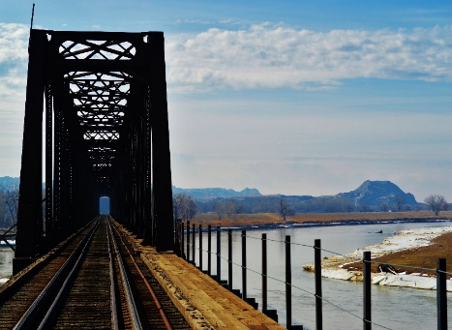

Black Bridge; Glendive, MT

Glendive Parks
- Lloyd Square Park
N. Kendrick Ave/ N. Meade Ave
Public swimming pool, picnic shelter, basketball court, tennis courts, playground, horseshoe pits, and public restrooms.

- Jaycee West Park
Park Ave, Glendive
Tennis Courts, horseshoe pits, sand volleyball, Skate Park, basketball court, picnic area and public restrooms.

- Eyer Park
W. Towne St/ W. Bell St
Playground, multi-purpose field, picnic area and restrooms.

- Whipkey Park
S. Taylor Ave/ S. Sargent Ave.
Baseball field, Splash Park, ice rink, basketball court, playground, picnic area and public restrooms.

- Penninger Park
N. River Ave
Basketball courts, picnic area and bird watching.

- Greg Park (Forest Park)
Linden Ave/Oak Street
Baseball/Softball fields, basketball courts, tennis courts, multi-purpose field.

- Gazebo Park
South Merrill Avenue

- ABC Fields
N. Meade Ave
Baseball for 5 – 12 year olds. Summer league, concessions.

- GGSA Fields
Colorado Blvd.
Softball for girls ages 4 -14 years old, adult co-ed softball, concessions and restrooms.

- Meissner Field
Colorado Blvd
American Legion Baseball for boys 16-18 years old.

- DCC Outdoor Recreation Complex
Patt Street/DCC
Baseball fields, softball fields, and sledding.

- Hollecker Lake/Park
HWY 16/Olmstead Dr.
Fishing, picnic area, sand volleyball, boat ramp (check regulations), swimming and a handicap accessible fishing area.

- Maple Park (Hillcrest)
Maple Ave
Basketball Courts, Picnic Area.

- Lions Park (Hillcrest)
Sunset Ave/Hillcrest Ave
Basketball courts and playground.

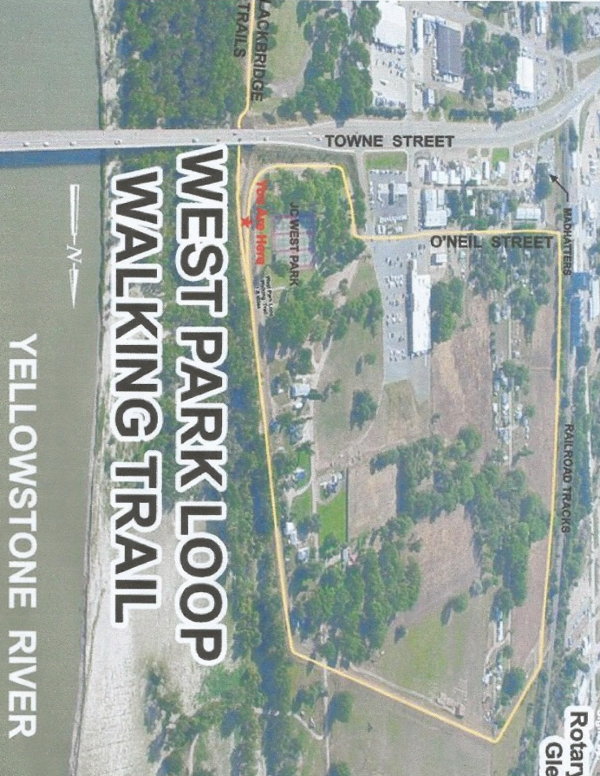
City Parks
Walking Trails
Dawson Community College
Disc Golf Courses
Disc Golf Courses

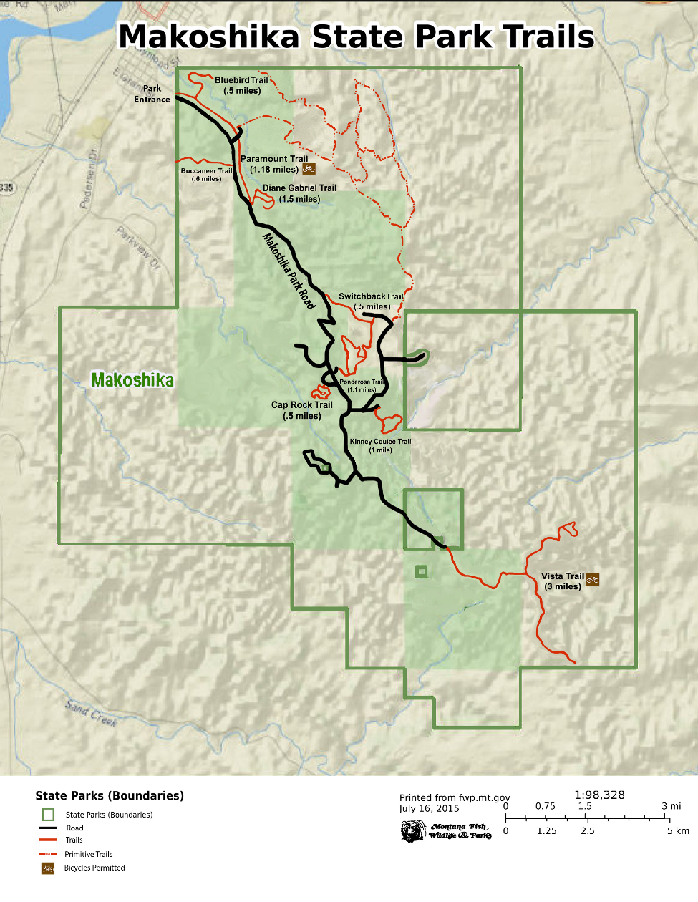
Hiking Trails
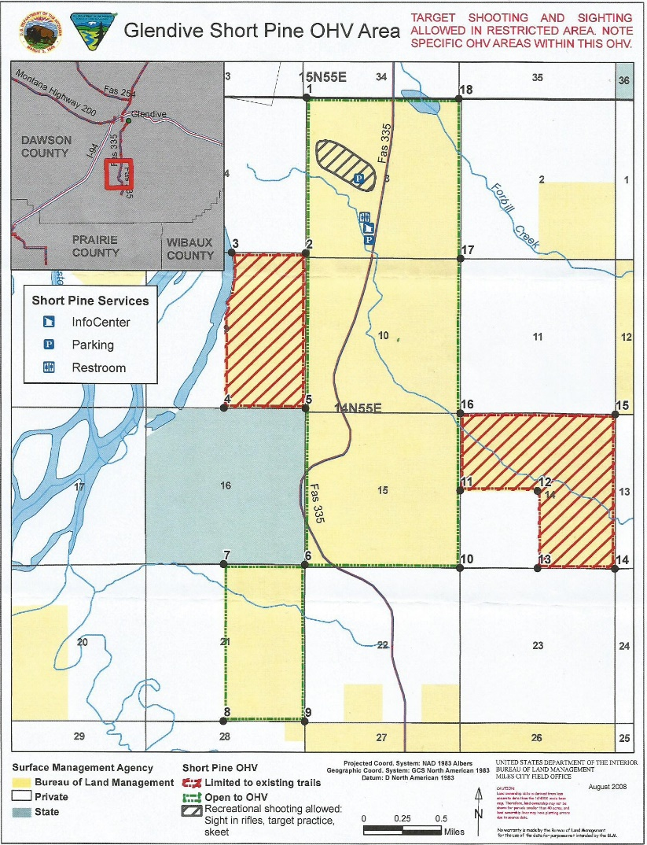
Off-Highway Vehicle Trails

This guide will be updated periodically. Please notify us of any corrections or additions that need to be made.
Thank You.

Glendive Recreation Department
Location: 314 N. River Ave
Mailing: 300 S. Merrill
Glendive, MT 59330
406-377-5471
recdept@midrivers.com
www.glendiverec.com

